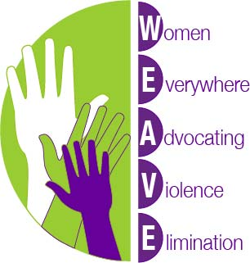 Convenor: Dr Elspeth McInnes
Phone: 61 8 83024042
Media Release: WOMEN’S LIVES LOST TO DOMESTIC VIOLENCE HONOURED IN PARLIAMENT THROUGH NATIONAL QUILT HANGING
Federal Parliament House, the House of Representatives Alcove, Canberra
Wednesday 19th June at 3.45pm.
The lives of women who have died from domestic violence are being honoured in Australia’s federal Parliament with the hanging of a commemorative quilt, hand-stitched by survivors from around Australia.
Every year 75 Australian women are killed by their partners or ex-partners, according to national homicide data.
Every year violence against women is the single largest contributor to the public health burden of illness, injury and premature death for women aged 15-45.
The tragic waste of lives due to domestic violence is the message of the national quilt project coordinated by Women Everywhere Advocating Violence Elimination (WEAVE Inc.).
The quilt’s hanging in the Alcove of Parliament House at 3:45pm on June 19 will be attended by Members of Parliament and members of the public in recognition of the lives lost and the promise of lives being saved through focused action to reduce and prevent domestic and family violence.
WEAVE Convenor, Dr Elspeth McInnes AM, said the deaths were the visible ‘tip of the iceberg’ with researchers identifying that around 1 in 3 Australian women were exposed to domestic violence, and one in four Australian children had witnessed violence towards their mother by a father or step-father. ‘Apart from death and injury, the long term flow on effects of living with family violence include higher risks for adult and child survivors of conditions such as post-traumatic stress disorder, depression and anxiety, addictive behaviours, cardiovascular diseases and auto-immune conditions. Children’s lives can be blighted before they begin, with violence contributing to miscarriages, premature births, low weight babies, developmental delays and poor social and learning outcomes,’ Dr McInnes said.
Dr McInnes called for all states and territories to urgently implement domestic violence death review processes in cooperation with the Commonwealth to learn more about systemic reforms needed to reduce the severe but preventable toll of violence on Australia’s women and children.

